# DAD 220 Module Two Activity Template

Replace the bracketed text in this template with your answers and any supporting screenshots. Then submit it for the Module Two table and SQL identification activity. You’ll need to download this template, save it as a unique file, and then submit it for grading. Rename this document to include your last name, and remove these instructions before submitting.

Using the tables and SQL statements from the prompt for Module Two Activity, answer the following questions. Replace the bracketed text with your answers and any supporting screenshots.

1. How many records are shown in the Employee table?

5

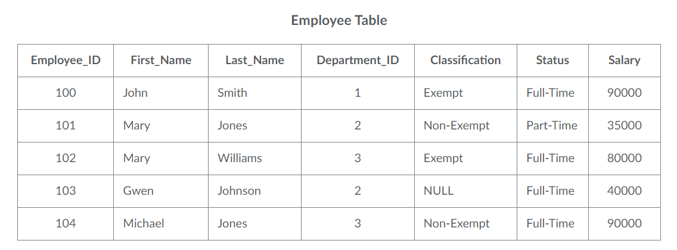

1. How many attributes are there in the Branches table?

2

1. Which attribute could be a primary key for the Employee table?

Employee_ID

1. How many decimal places (maximum) can be stored in an employee’s salary field?
2. How many decimal places (maximum) can a Department_ID have?

2

1. What three rules do tables obey?

Tables are normalized. No duplicate rows. No duplicate Names.

1. Is the Employee table normalized? How do you know?

Each cell only contains one value

1. What is the result of the following query?

- Select sum(Salary) from Employee where Department_ID=3;

170000

1. How many rows are returned as a result of the following query?

Select * from Employee where Classification<> 'Exempt';

2

1. What is the result of the following query?

- Select max(Salary) from Employee;

90000